**Building A New Restaurant in Gurgaon neighbourhood**

**Aim of Project**

The aim of this project is to determine which would be the best area to set up a new restaurant in the city of Gurgaon, India.

**Introduction**

**Gurgaon**, officially **Gurugram**, is a city located in the northern Indian state of [Haryana](https://en.wikipedia.org/wiki/Haryana). It is situated near the [Delhi](https://en.wikipedia.org/wiki/Delhi)-[Haryana](https://en.wikipedia.org/wiki/Haryana) border, about 30 kilometres (19 mi) southwest of the national capital [New Delhi](https://en.wikipedia.org/wiki/New_Delhi) and 268 km (167 mi) south of [Chandigarh](https://en.wikipedia.org/wiki/Chandigarh), the state capital. It is one of the major satellite cities of Delhi and is part of the [National Capital Region of India](https://en.wikipedia.org/wiki/National_Capital_Region_(India)). As of 2011, Gurgaon had a population of 876,900.

Gurgaon has become a leading financial and banking centre in India after Mumbai and Chennai. The city's economic growth story started when the leading Indian automobile manufacturer [Maruti Suzuki India Limited](https://en.wikipedia.org/wiki/Maruti_Suzuki) established a manufacturing plant in Gurgaon in the 1970s. Today, Gurgaon has local offices for more than 250 [Fortune 500](https://en.wikipedia.org/wiki/Fortune_500) companies. Gurgaon is categorised as [very high](https://en.wikipedia.org/wiki/List_of_districts_of_Pakistan_by_Human_Development_Index) on the [Human Development Index](https://en.wikipedia.org/wiki/Human_Development_Index), with an HDI of 0.889 (2017), which is also the highest in India.

**Neighbourhoods**

Gurgaon is divided into 36 wards, with each ward further divided into blocks. The housing type in the city consists largely of attached housing, though many attached [multi-dwelling units](https://en.wikipedia.org/wiki/Multi-dwelling_unit), including [apartments](https://en.wikipedia.org/wiki/Apartment), condominiums and [high rise residential towers](https://en.wikipedia.org/wiki/Tower_block) are getting popular.

**Business Problem**

There are many malls, offices and restaurants located in Gurgaon. But the range of the restaurants in terms of finance is either too high or too low. Most of the restaurants are located around areas for shopping and partying. The areas around the offices mostly lack in good restaurant service. So, through this project I will find a suitable place which requires a good, formal restaurant in the mid-range.

**Target Audience**

The target audience of the project would be anybody interested in opening a new restaurant which serves in the middle range in Gurgaon.

The target audience of the business would be mostly middle-class office going people. The restaurant could be serving as a café to a light refreshments place, for a formal after office party or a small lunch place.

**Data**

Data for this project is from a site called <https://www.kaggle.com/karansud/neighborhoods-of-gurgaon-with-latlong>. It has the neighbourhoods of Gurgaon and latitude and longitude information of the neighbourhoods. The data will be loaded in the form of a csv file downloaded from this site. Also the restaurant information and office locations will come from Foursquare location data.

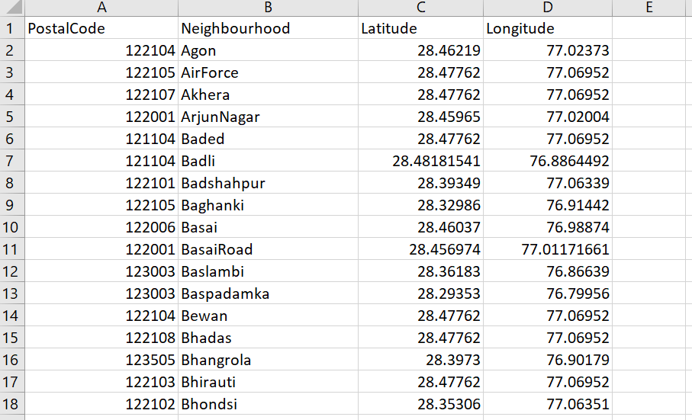

The Foursquare location data will provide the nearby restaurant information.

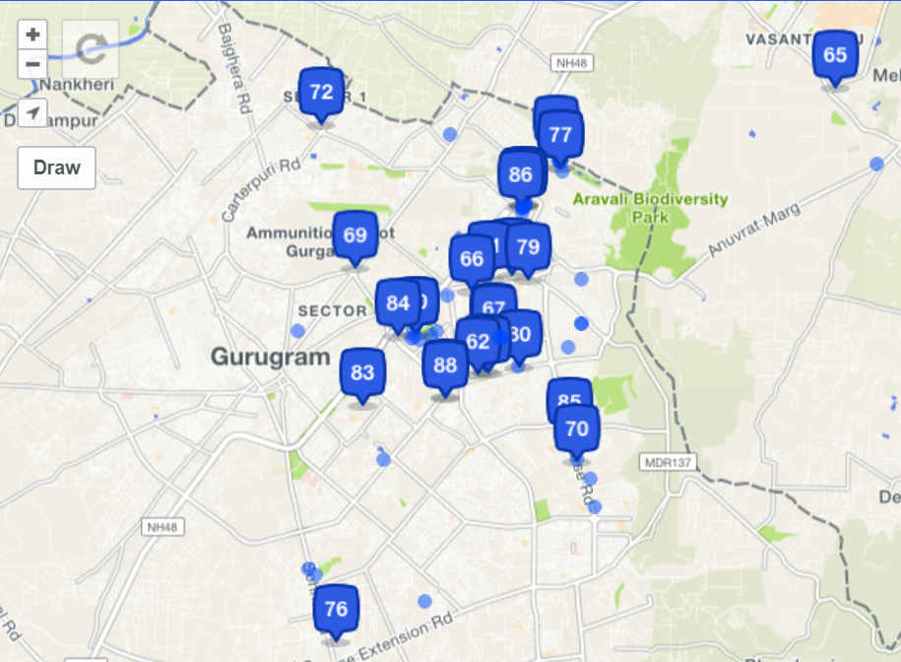

**Methodology**

The data with the neighbourhood, latitude and longitude information was loaded into a dataframe from the csv file.

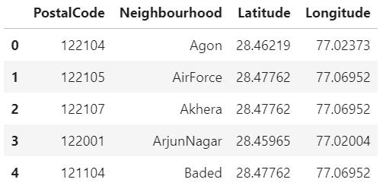

After gathering all these coordinates, I visualized the map of Gurgaon using Folium package.

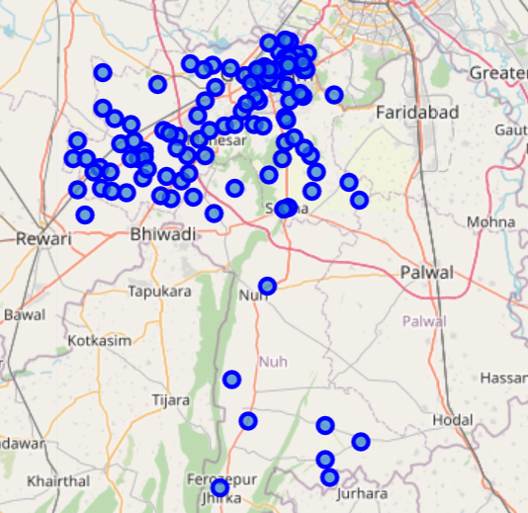

Next, Foursquare API was used to pull the list of top 100 venues within 500 meters radius. A Foursquare developer account was created in order to obtain CLIENT_ID and CLIENT_SECRET to pull the data From Foursquare, the venues in each neighbourhood and their respective latitude and longitude was obtained.

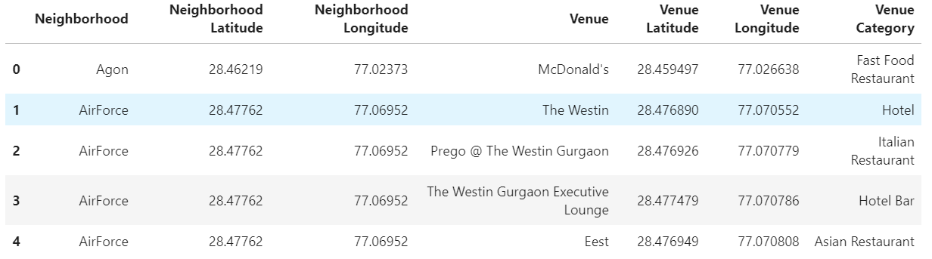

Then the venues were filtered to have just restaurants.

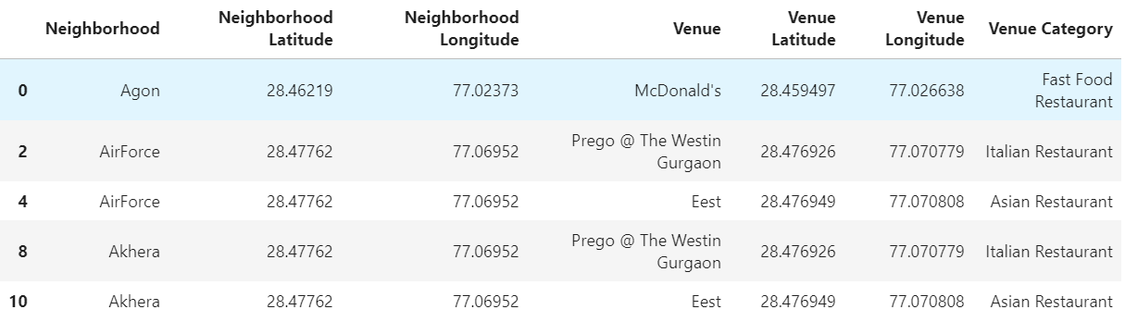

Then they were grouped by neighbourhoods to find how many restaurants are there in each neighbourhood and the mean of frequency of occurrence of each neighbourhood is taken.

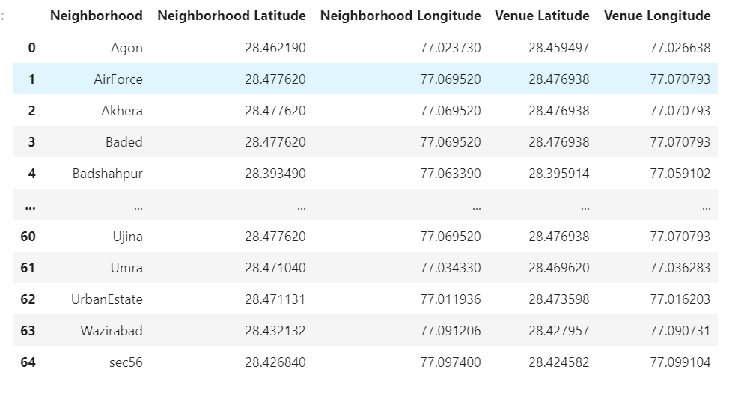

Lastly, k-means clustering is performed. K-means clustering algorithm identifies k number of centroids, and then allocates every data point to the nearest cluster, while keeping the centroids as small as possible. The clusters have been divided into 3 and then clustering is done. The cluster labels were added to the grouped dataframe. Then the map of the clusters is shown using folium.

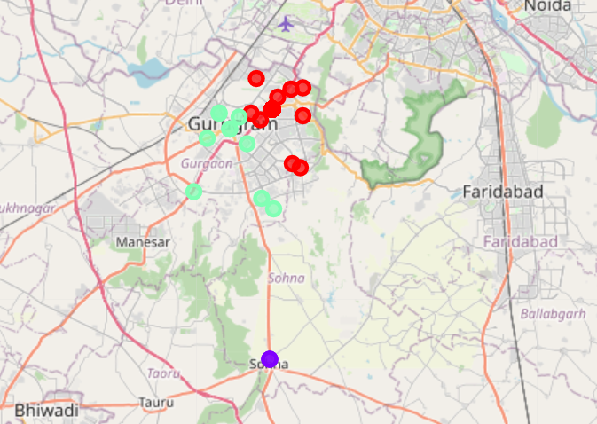

Then each cluster is divided to show the neighbourhood and restaurants in that neighbourhood.

**Results**

The three clusters formed are as follows:

Cluster 0: It has 54 neighbourhoods having restaurants

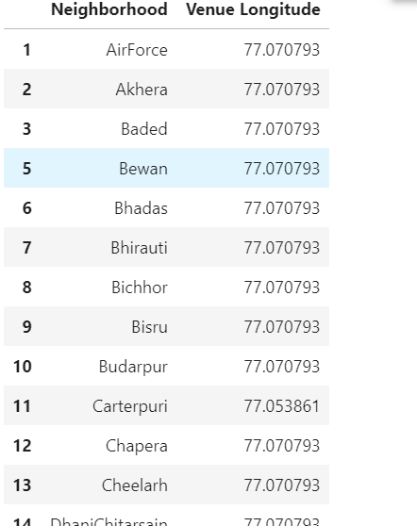

Cluster1: It has 2 neighbourhoods having restaurants

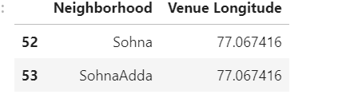

Cluster 2: It has 10 neighbourhoods having restaurants

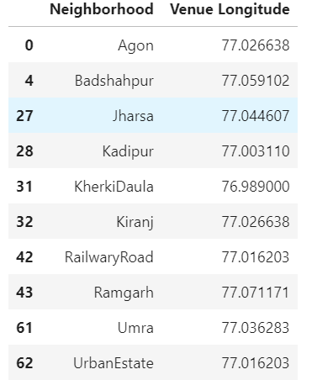

So cluster 1 is the best choice to build a new restaurant.

**Discussion**

Now the further discussion could be the area around which the restaurant could be set up. The population density of the areas in the cluster and the market places, malls, offices in the area around the neighbourhood so more people would frequent the restaurant. The type of restaurant that people would enjoy in the neighbourhood. The communication lines and routes to the neighbourhoods and its distance from the centre of the city.

**Conclusion**

From this model the conclusion can be derived that setting up a new restaurant in the neighbourhoods around cluster 1 would be recommended. There are many others factors which should be taken into account for the best place to set it up.

**References**

Neighbourhood data from <https://www.kaggle.com/karansud/neighborhoods-of-gurgaon-with-latlong>.

Foursquare Api

<http://www.zinkohlaing.com/data-science/using-machine-learning-to-find-locations-to-open-a-burmese-restaurant-in-toronto-ibm-capstone-project/>